Business Process: Meter Reprogramming

Contact
Business Process Owner | Field Metering
Subject Matter Expert(s) | Billing Performance Revenue Analysts: Wendy Cates and Salvador Torres. Sr. CSR: Marty Manzanares and Rob Rose  Meter Shop Sr. Meter Technicians: Michael Vasquez and David Righer  Information Technology Supervisor and Enterprise Technology Analyst-Journey: Keng Wah “Peter” Wong and Rajesh Pandey
Key Contact | Supervisor, Billing Performance, Supervisor Information Technology – Steve Van Horrsen and Keng Wah “Peter” Wong, Field Metering Supervisor – Brandon Miller
Key Role | Billing Performance Revenue Analyst and Sr. CSR, Sr. Meter Technician, Enterprise Technology Analyst, Supervisor Information Technology
Date Created | 04/21/2026

Business Process Overview
Meter reprogramming at SMUD ensures that customers’ meters are accurately configured to record energy usage. This process allows SMUD to update meter settings remotely or in the field, accommodating rate changes, service upgrades, or meter replacements, and maintaining billing accuracy and operational efficiency.

Business Process Assumptions
(Assumptions pertaining to the business process)
Process | - The process can be used for mass reprogramming, single meter reprogramming, or small batch weekday reprogramming.  - Integrations between UIQ, SAP, and IEE are working as expected so that all systems are synced
People | - Billing Performance Revenue Analyst and Sr. CSR  - Meter Shop Sr. Meter Technician  - Information Technology Enterprise Technology Analyst – Journey  - Information Technology Supervisor
Technology | - SAP  - UIQ  - IEE

Process Flowchart
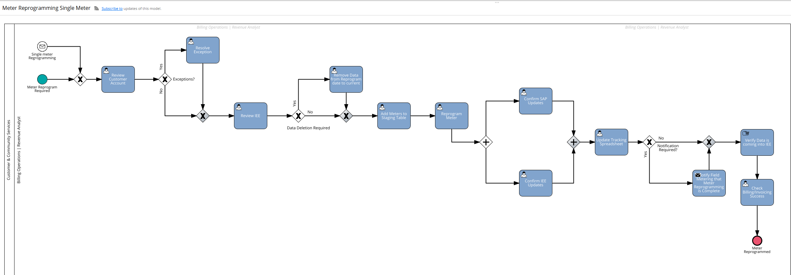

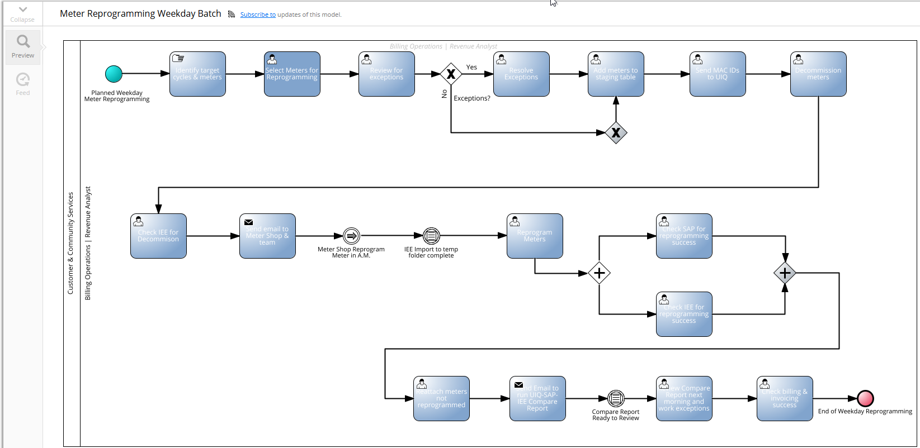

Task Description
Id | Task Description | Procedure
 |  | Meter Reprogramming – Single Meter
 | Review Customer Account | - Checking to see if there is an active customer, disconnect document, active customer vs inactive customer
 | Resolve Exceptions | - There can be different exceptions, and not all exceptions will be worked (exclusion list, no active contract, open bill order, etc.,). Note: There is more flexibility with resolving exceptions in the single meter process.
 | Review IEE | - Checking for data (gap missing needs to be deleted)  - Check configuration sometimes
 | Remove Data from Reprogram Date to Current | - This work is performed in IEE – Details not required
 | Add Meter to Staging Table | - Run SAP transaction ZCS_PRG  - Enter meter number(s)  - Enter effective date = same as reprogramming date  - Select processing option: File Report – Table update  - User must select Maximum no. of hits before executing this transaction to control number updated to the Staging Table  - Use this option only after Exception Report has been reviewed and exceptions left or cleared  - Execute
 | Reprogram Meter | - Run SAP transaction ZCS_MRP  - Enter meter number(s)  - Update the effective date = same day as meter reprogramming  - Execute (will show any exceptions)  - Highlight meters to be reprogrammed, then click on meter reprogramming  - Output: Messaging that indicates success
 | Confirm SAP Updates | - Access accounts via SAP transaction ZCSBH and check for the following:  - Meter register group  - Meter swap  - Class overview and profile
 | Confirm IEE Updates | - Work is performed in IEE – details not required
 | Update Tracking Spreadsheet | - Located on Billing SharePoint:
 | Notify Field Metering Reprogramming Complete | - Email Field Metering to advise that meter reprogramming is complete  - Note: this action happens when Billing receives an email notification from Field Metering to reprogram meter
 | Verify data is coming into IEE | - Worked performed in IEE – Details not required
 | Check Billing & Invoicing Success | - Access SAP transaction ZCSBH and review invoices to ensure accounts billed/invoiced correctly after meter reprogramming  - Note: this is necessary when there is an Active customer only
 |  | - Meter Reprogramming – Weekday Small Batch
 | Identify Target Cycles & Meters | - Manual process reviews SAP calendar to identify which cycle(s) are coming up for billing  - Run SAP transaction ZCS_PRG to extract list of meters that are not reprogrammed
 | Select Meters for Reprogramming | - Access SAP transaction ZCS_PRG (can search by equipment number, device location, meter program id, and metr serial number. Also, by billing cycle/mru/rate cat).  - Enter effective date = same as reprogramming date  - Select a processing option (File Report or ALV Report – No table update) and execute
 | Review for Exceptions | - Review report with exceptions
 | Resolve Exceptions | - There can be different exceptions, and not all exceptions will be worked (exclusion list, no active contract, open bill order, etc.,)
 | Add Meters to Staging Table | - Run SAP transaction ZCS_PRG  - Copy and paste list of meters  - Enter effective date = same as reprogramming date  - Select processing option: File Report – Table update  - User must select Maximum no. of hits before executing this transaction to control number updated to the Staging Table  - Use this option only after Exception Report has been reviewed and exceptions left or cleared  - Execute
 | Send MAC IDs to UIQ | - From SAP transaction ZCS_PRG  - Select processing option: MAC Id report  - User must select Maximum no. of hits before executing this transaction  - Execute
 | Decommission Meters | - Run SAP transaction ZCS_DECOM  - Paste list of meters  - Execute (will create a single export file per meter that is saved to a folder in SAPIFS)  - Drop individual files into the ConfigurationImport folder in IEE
 | Check IEE for Decommission | - Work is performed in IEE – details not required
 | Meter Shop Reprogram Meters | - Meter Shop will reprogram meters in UIQ in the A.M.
 | IEE Import to Temp Folder | - IT will redirect the IEE Import to a Temp Folder until reprogramming is completed (happens early in the morning)
 | Reprogram Meters | - Run SAP transaction ZCS_MRP  - Paste list of meters into transaction  - Update the effective date = same day as meter reprogramming  - Execute (will show any exceptions)  - Highlight meters to be reprogrammed, then click on meter reprogramming  - Output: Messaging that indicates success
 | Check SAP for Reprogramming Success | - Access accounts via SAP transaction ZCSBH and check for the following:  - Meter register group  - Meter swap  - Class overview and profile
 | Check IEE for Reprogramming Success | - Work is performed in IEE – details not required
 | Reattach Meters Not Reprogrammed | - Work is performed in IEE – details not required
 | Send Email to Run Compare Report | - Email is sent to Information Technology to run the SAP_IEE_UiQ Compare report
 | Run Compare Report | - Report is run in the background in SAP and takes multiple hours to complete
 | Review Compare Report & Work Exceptions | - Review the SAP_IEE_UIQ Compare Report – this report displays mismatches in meter configuration between the 3 systems.
 | Check Billing & Invoicing Success | - Access SAP transaction ZCSBH and review invoices to ensure accounts billed/invoiced correctly after meter reprogramming

Business Rules
Id | Event Name | Business Rules
 | Identify Target Cycles & Meters | - Cannot select cycles that are in the prep window
 | Resolve Exceptions | - Do not reverse an open bill order
 | Decommission Meters | - Must decommission meter to prevent the creation of 15 or 60 minute buckets
 | Meter Shop Reprograms Meters | - Must be completed the morning of the selected reprogramming date
 | IEE Import to Temp Folder | - Must be completed in the A.M. to prevent data import issues
 | Reprogram Meter | - Must be done the same day meters are reprogrammed in UIQ by Meter Shop

Event | Legal Requirements, Rules, and Regulations  Legal documents/ procedures/ requirements to be fulfilled before/at the specified event.
Id | Event | Legal Requirements, Rules and/or Regulations
N/A

Pain Points and Improvement Opportunities
- Do not have access to the SAP staging table to make updates which caused issues during the process
- For testing, the UIQ QA environment is not connected to SAP or IEE QA environments to validate end to end testing
- The UIQ QA environment does not have all devices populated to facilitate end to end testing
- The reprogramming process is clunky and involves lots of moving parts and people – would love to have a more streamlined process

Departments impacted by process change (Required)

Department | Type of Change(s) | Action Required
Billing Performance
Field Metering

Supporting Documentation
(Any subsequent documentation in support of this business process (i.e. business requirements, technical specs, etc.) shall be summarized in the following table.)
Document Type | Link
Signavio Process Map | *Meter Reprogramming Weekday Batch | SAP Signavio
Signavio Process Map | Meter Reprogramming Single Meter | SAP Signavio
Policy and Procedure

Business Blueprint Amendments

Any subsequent changes to this business process blueprint after the official document approval shall be summarized in the following table. This document must be reprinted and signed by the authorized representatives.
Version | Author | Description of Change | Approval (Name/Sign) | Date
V1 | Anand Padhye | Initial draft
V2 | Sabrina Hudson | Revised draft | Approved by Lisa Gallegos on May 19, 2026

